**Installing Wikibase on Docker**

This document describes the steps to follow for installing and configuring Wikibase latest version on Docker running on CentOS 7.

1. **Install Docker on CentOS 7**
   1. Before the installation, if any older versions of Docker are already installed uninstall them with the following commands.

**sudo yum remove docker \**

**docker-client \**

**docker-client-latest \**

**docker-common \**

**docker-latest \**

**docker-latest-logrotate \**

**docker-logrotate \**

**docker-engine**

* 1. To install, add Docker repository to the repo list of the host machine

**sudo yum install -y yum-utils**

**sudo yum-config-manager \**

**--add-repo \**

**https://download.docker.com/linux/centos/docker-ce.repo**

* 1. Then install latest version of Docker engine

**sudo yum install docker-ce docker-ce-cli containerd.io**

* 1. To Start Docker run the command below

**sudo systemctl start docker**

* 1. Docker should now be installed, the daemon started, and the process enabled to start on boot.

The status of the Docker installation can be checked with the command below,

**sudo systemctl status docker**

**The output should be similar to the following, showing that the service is active and running:**

**Output:**

docker.service - Docker Application Container Engine

Loaded: loaded (/usr/lib/systemd/system/docker.service; enabled; vendor preset: disabled)

Active: active (running) since Mon 2021-01-04 19:54:03 JST; 1 day 17h ago

Docs: https://docs.docker.com

Main PID: 8956 (dockerd)

1. **Fetch and Start Wikibase Docker image**
   1. Install Docker-compose

sudo curl -L https://github.com/docker/compose/releases/download/1.27.4/docker-compose-`uname -s`-`uname -m` -o /usr/local/bin/docker-compose

chmod +x /usr/local/bin/docker-compose

* 1. Go to the location where docker and docker-compose are installed.

**Note:** To find the installation location use: **sudo find / -name docker-compose**

* 1. Download the docker-compose file to the above location with the following command.

**sudo wget https://raw.githubusercontent.com/wmde/wikibase-docker/master/docker-compose.yml**

* 1. In the directory that contains the docker-compose.yml file, run the following to pull the needed Docker machine images.

**sudo docker-compose pull**

* 1. Start the machine images in the background

**sudo docker-compose up -d**

(To view the continuous log output, run **docker-compose logs -f**)

* 1. Use the command below to view all the services that has been started

**sudo docker-compose ps**

**Output:**

**Name Command State Ports**

**-------------------------------------------------------------------------------------------------------------------------**

**bin_elasticsearch_1_153d06232b02 /usr/local/bin/docker-entr ... Up 9200/tcp, 9300/tcp**

**bin_mysql_1_98bd69a2f5c8 docker-entrypoint.sh mysqld Up 3306/tcp**

**bin_quickstatements_1_e891769db85a /bin/bash /entrypoint.sh Up 0.0.0.0:9191->80/tcp**

**bin_wdqs-frontend_1_bfb375001f18 /entrypoint.sh nginx -g da ... Up 0.0.0.0:8282->80/tcp**

**bin_wdqs-proxy_1_80cbe1d38f48 /bin/sh -c "/entrypoint.sh" Up 0.0.0.0:8989->80/tcp**

**bin_wdqs-updater_1_f26c47c6ce0f /entrypoint.sh /runUpdate.sh Up**

**bin_wdqs_1_e573d9c29123 /entrypoint.sh /runBlazegr ... Up 9999/tcp**

**bin_wikibase_1_baf49da91847 /bin/bash /entrypoint.sh Up 0.0.0.0:8181->80/tcp**

* 1. Now, Wikibase is up and running in default ports below.

**http://localhost:8181 - Main Wikibase**

**http://localhost:8282 - Query service**

**http://localhost:9191 – Quick statements**

* 1. To open the web application, use the following.

From a web browser access the URL: http://<host machine IP>:8181/

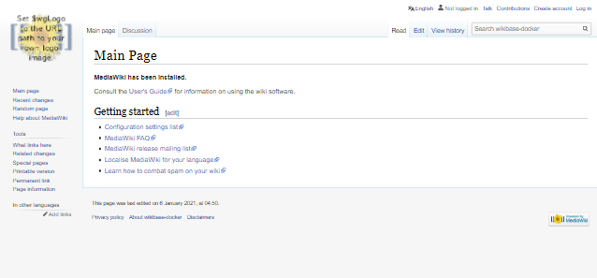

Login to default administrator account use following credentials.

**Username**: WikibaseAdmin

**Password**: WikibaseDockerAdminPass

1. **Wikibase main functions**
   1. Adding users,

From the left side menu under Tools, click **Special Pages → Create account** (under the "Log in / Create account" heading).

* 1. To change the privilege levels: **admin, non-admin, bot**

Click on username in the main menu, then from the left side menu under Tools, click **Change user groups -> User rights**

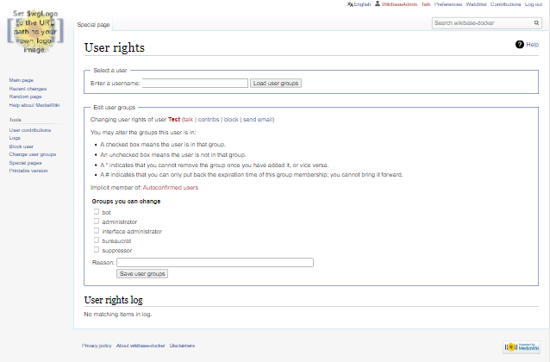

* 1. Creating classes,

To create an item, from the left side menu under Tools, click **Special Pages → Create a new item** (under the "Wikibase" heading). Then add a label, a description, and some aliases for the item.

* 1. Creating properties,

To create a property, from the left side menu under Tools, click **Special Pages → Create a property** (under the "Wikibase" heading). Then add a label, description, some aliases for the property, and choose a data type.

* 1. Creating pages,

To create a page, from the main search menu search by page name. (Ex: if we want to add a page with name “Earth”, search by typing “Earth” in the search box as follows).



Then click on the search icon and it will open the following page.

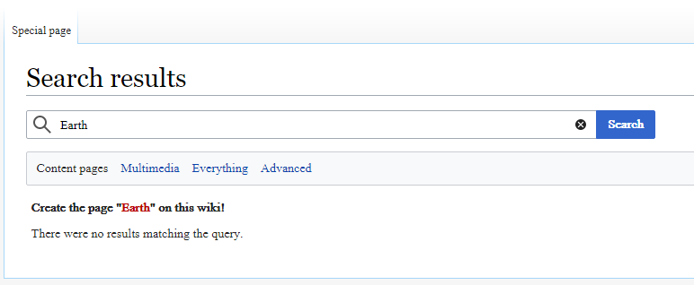

From above page click on the red colored “Earth” text. It will open following page. Enter a text and a summery for the page and save it.

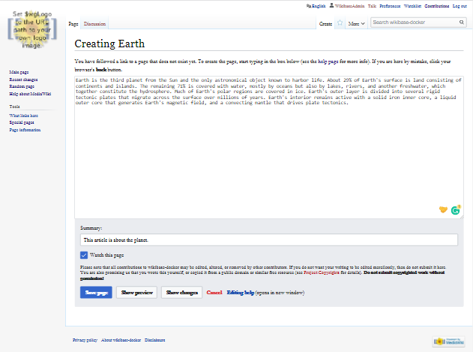

It will create a wiki page with name “Earth” as follows.

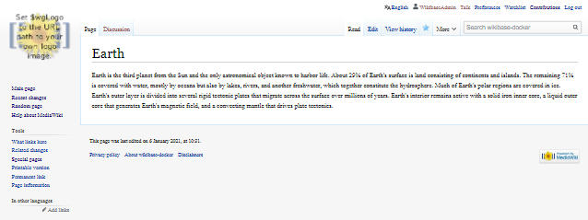

* 1. Adding a custom logo
     1. View docker containers running in host machine.

**sudo docker ps**

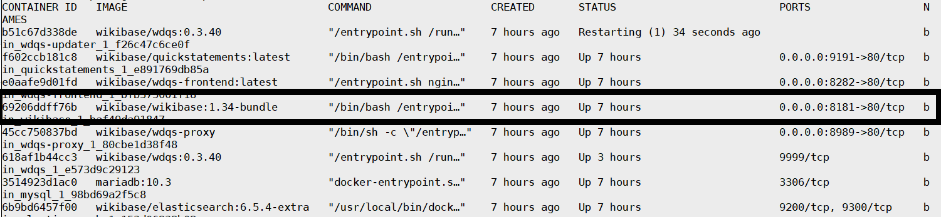

* + 1. Find the Container id of the image **Wikibase/wikbase:1.34-bundle**.
    2. Then, copy new logo image with size 135x135 to the docker container using following command.

**sudo docker cp <host path>/<image name> <ContainerID>:/var/www/html/images/**

* + 1. Next copy LocalSettings.php in the docker container to the host machine.

**sudo docker cp <ContainerID>:/var/www/html/ LocalSettings.php <host path>**

* + 1. Edit LocalSettings.php by adding following PHP code to end of the file.

**$wgLogo = "$wgResourceBasePath/images/<image name> ";**

* + 1. Copy LocalSettings.php back to the docker container.

**sudo docker cp <host path>/ LocalSettings.php <ContainerID>:/var/www/html/**

It will show the new logo in the **Main Wikibase** web application**.**

